Lab # 10
More About Functions in C++

Objective
To understand advanced concepts of functions in C++ such as:
- Function with parameters
- Function with return value
- Function calling with arrays
- Reusability of code using functions

Apparatus / Software Required
- Computer
- C++ Compiler (Code::Blocks / Dev C++ / Online Compiler)

Theory
Functions in C++ are used to divide a program into small parts.
Each function performs a specific task.

Key Points
- Functions can take parameters (inputs)
- Functions can return values
- Functions help in code reuse
- They make programs simple and organized

Example:

Program:

Function with parameter and return value
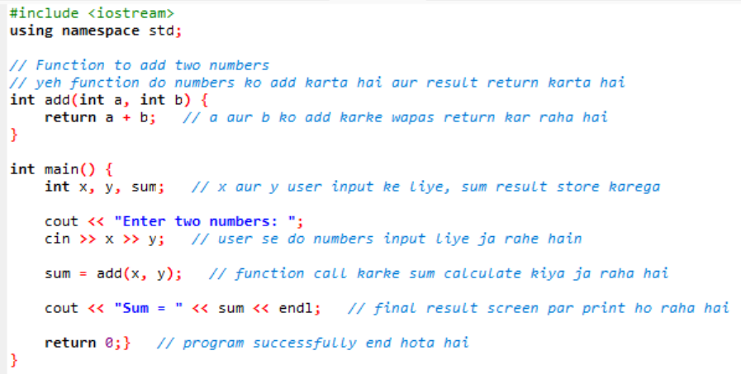

Working
- The function add() takes two numbers as input
- It returns their sum
- In main(), user inputs two values
- Function is called and result is displayed

Output Example
Enter two numbers: 5 7
Sum = 12

Conclusion
In this lab, we learned how functions can take inputs and return values. Functions make programs more efficient, reusable, and easy to understand.

Lab 10 Tasks
1. Function with Parameters
▪ Declare a function called ”multiply” that takes two integer
parameters:”num1”and”num2”.
▪ Inside the function, calculate the product of the two
numbers.
▪ Display the result within the function.
▪ Call the function from the main program, passing two numbers, to perform
the multiplication

Code:

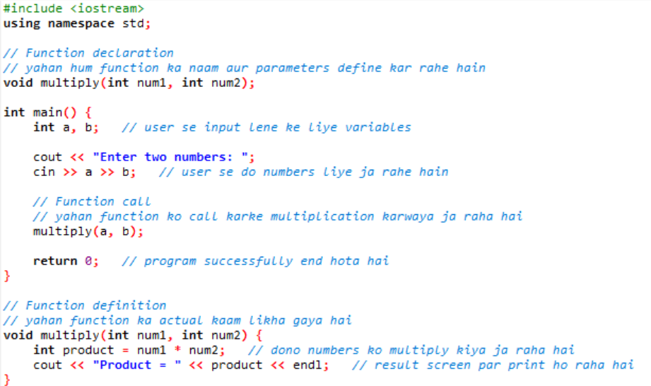

2: Function with Return Value
▪ Declare a function called ”getSquare” that takes an integer parameter:
”number”.
▪ Inside the function, calculate the square of the number.
▪ Return the result.
▪ Call the function from the main program, passing a number, and display
the square.
Code:
